**Lab03 Report**

**Sep 2022**

**Problem 1. Types of Edges**

**Problem 2. Intensity Based Edge Detection**

Thresh=15

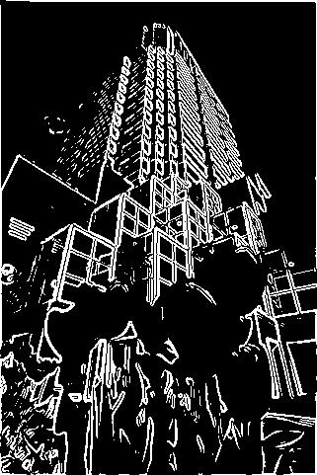

Thresh=10

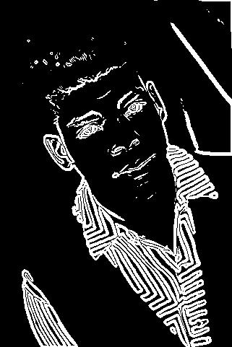

Thresh=15

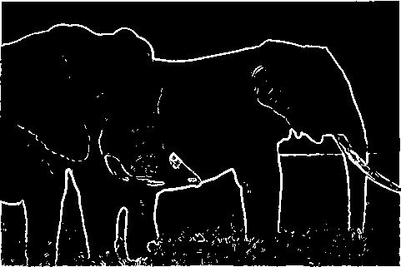

Thresh=15

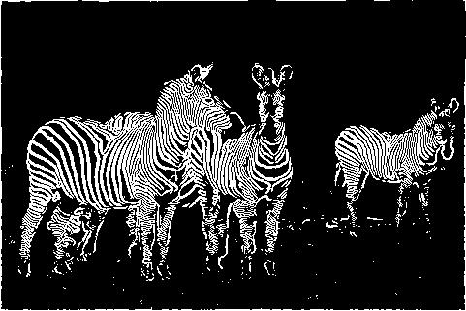

Thresh=30

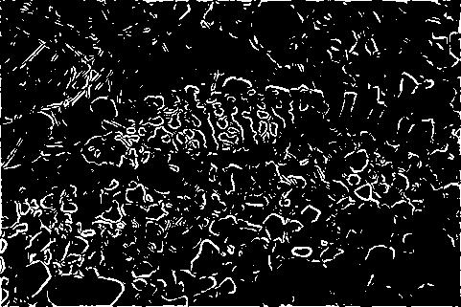

Thresh=20

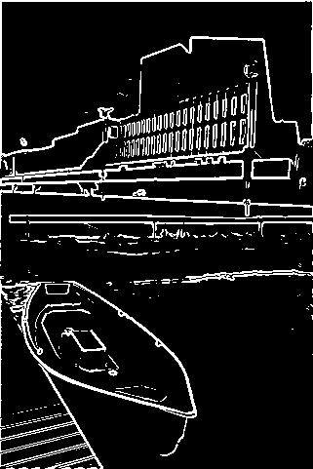

**Problem 3. Canny Edge Detector**

Output images with Thresh=[0.3,0.5], and sigma=sqrt(2)(defalut)

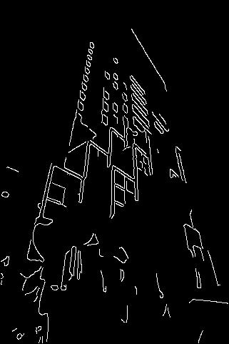

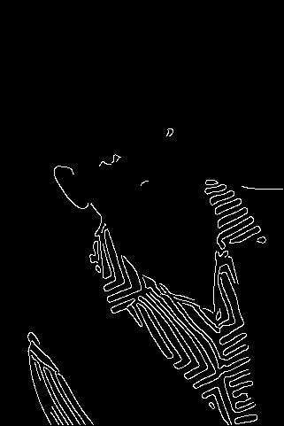

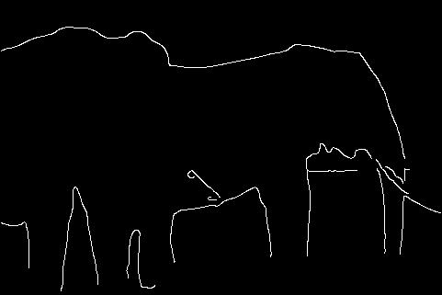

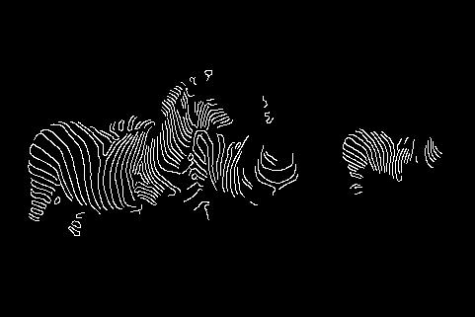

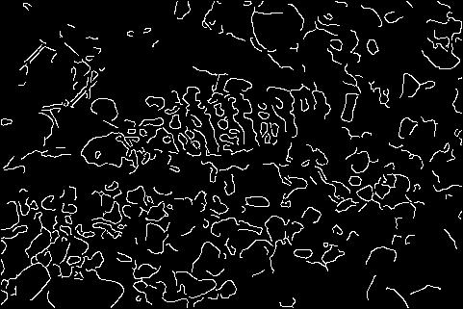

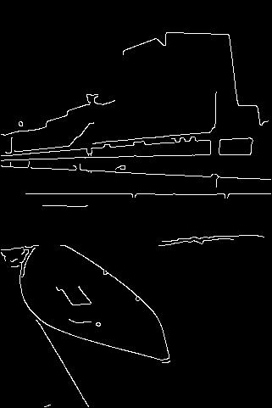

Q1: Canny edge detector performs better when dealing with noise and detect the real edges, though the edges may not be fully detected, and it outputs very accurate and clean edges.

Canny edge detector’s weakness is that it loses weak edge information when filtering out the noises, and the parameters are not adaptable, thus we have to adjust them to cater for different images.

Q2: sigma decides the size of edges Canny() can detect, with small sigma, then the thin edges can be detected, while big sigma helps detect blur edges like the color joint edges.

The thresh decide what information will be kept, if the lower boundary is too small, then some noise and useless information will be kept, if higher boundary is too big, then much useful information will be omitted.

With same picture:

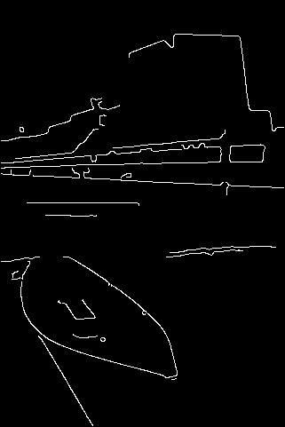

Left one with smaller sigma keeps more details.

The left one with wider thresh keeps more information even the non-edge information.

Q3: The edges in high contrast with surrounding pixels lead to big gradient, thus it will be highlighted by edge detector, then they are easily to be found.

**Problem 4. Histogram based edge detection**

The chi-square distance steps:

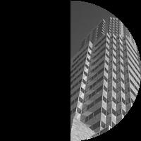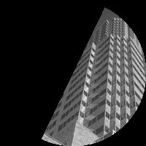…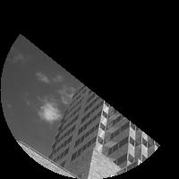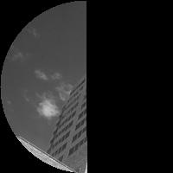..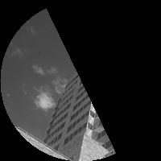

With radius=5, bins=16,num_orient=8, and thresh=1.6, the output image are as follows:

It is a bit disordered, I am not sure about if I did it in the wrong way.

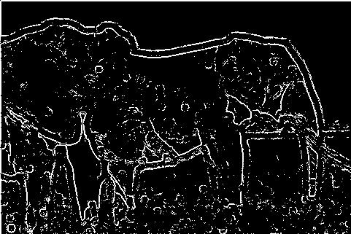

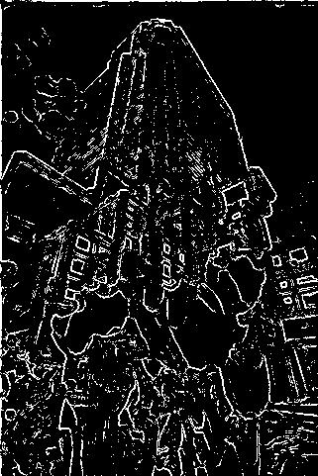

If with bigger rad, then output images:

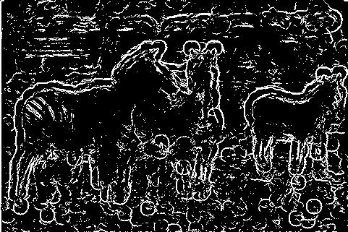

The edges are more thick and inaccurate, with circular pattern.

if with bigger bins, then output images:

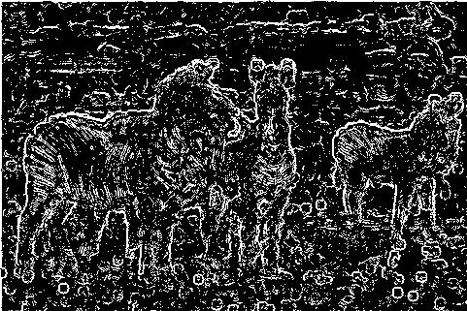

It seems that more information is recorded and it’s more disordered.

**Problem 5. Texture Based Edges**

I’ve tried many ways, but I still have problem with the Odd-symmetric and Even-symmetric filters, I think my codes are correct, thus maybe it’s because of my misunderstanding.

It costs a lot of time processing, thus I only tested bds3.jpg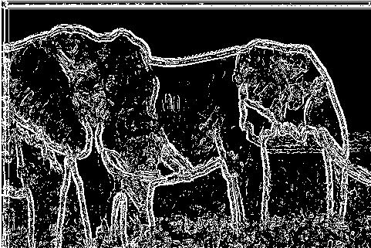

**Problem 6. Edge Linking**

The final binary edge map are as follows with [Tl,Th]=[19,20]:

With wider [Tl,Th]=[10,30], the edges become thicker and inaccurate as well, but it will reduce the useless information, examples are below:

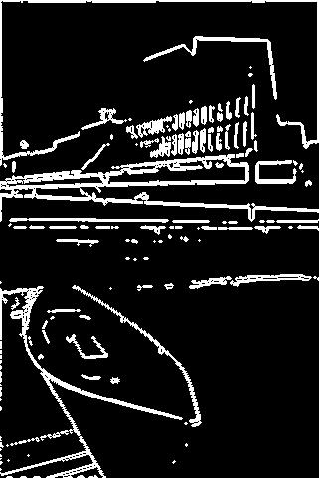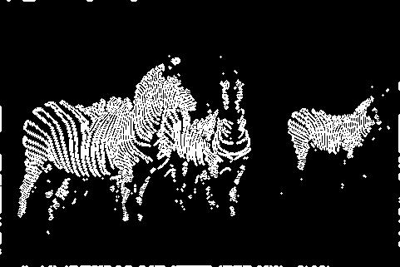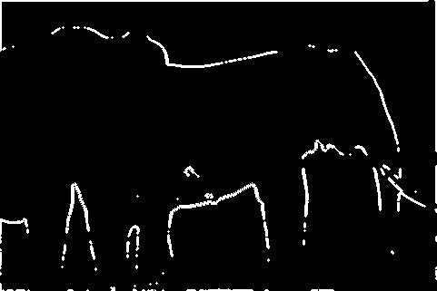

Summary:

The output images are stored in the folders accordingly, some of the codes may have flaws, please keep me informed if there is something wrong with my work.